Master builder

Introduction:

Migration of people to cities had become more common in Indian cities. As land is limited and population increasing day by day, results scarcity for land. Thus, construction had undergone many alternations in all field over past years, one among them is building **“skyscrapers”** .

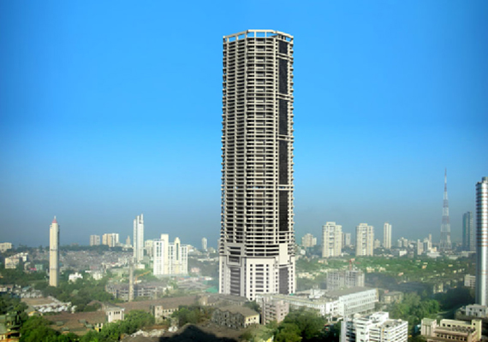

Problem statement:

Construct a skyscraper with the Aluminium rods, L-clamps and nuts& bolts. The following parameters should be kept in mind while construction

1. Height of the structure
2. Weight of the structure.
3. Axial Load bearing capacity

Participants are required to assemble their pre –fabricated units at SHAASTRA

Specifications:

1. Each team should bring their own specified material .
2. The weight of your structure should not exceed 2 kg.
3. The base area of the structure should not exceed 0.1 sq. m
4. Each aluminium unit should not exceed 40 cm.
5. L-clamp length should not be more than 5cm.

Testing criteria: Load will be applied **"AXIALLY".**

1. Height of the structure is measured and noted as “H m”
2. Weight of the structure is measured and noted as “W kg”
3. The load is added to the structure till failure. The load be “L kg”
4. Points awarded by professor is taken as “P”

Total score = ((L*H)/W) + P

Rules and Regulations:

1. Each team consists of maximum 4 members. Cross college teams are allowed
2. Each team should send their design as TDP (team description paper) through mail beforehand.
3. Time for each team is 4 hours and subject to change according to the conditions.
4. The participants will be given with screw driver

Penalties:

For every t min delay in construction, 0.5* t will be reduced from the total score.

**NOTE: All decisions by the coordinators are final and binding.**

Problem Statement, Rules and Scoring may change and all changes shall be reflected in the Shaastra website.

And hence, the teams are responsible for keeping themselves well informed about the event .

Keep visiting the website [www.shaastra.org](http://www.shaastra.org/) for updates regarding the event.

For any queries please mail [masterbuilber@shaastra.org](mailto:masterbuilber@shaastra.org)  with the subject as “Query:<query-topic>”